

***HOUSING PRICE PREDICTION***

**Submitted by:**

**Yunus Surty**

# ACKNOWLEDGMENT

I would like to thank Flip Robo Technologies for providing me with the opportunity to work on this project from which I have learned a lot. I would also like to thank my mentor in Fliprobo, Sapna Verma, for providing me with the dataset and problem statement for performing this wonderful task.

Some of the reference sources are as follows:

* Coding Ninjas
* Medium.com
* Analytics Vidhya
* StackOverflow

# INTRODUCTION

## BUSINESS PROBLEM FRAMING

The objective was to model the price of houses with the available independent variables. This model can then be used by the management to understand how exactly the prices vary with the variables. They can accordingly manipulate the strategy of the firm and concentrate on areas that will yield high returns. Further, the model will be a good way for the management to understand the pricing dynamics of a new market.

## CONCEPTUAL BACKGROUND OF THE DOMAIN PROBLEM

In real estate the value of property usually increases with time as seen in many countries. One of the causes for this is due to rising population.

The value of property also depends on the proximity of the property, its size its neighbourhood and audience for which the property is subjected to be sold. For example if audience is mainly concerned of commercial purpose. Then the property which is located in densely populated area will be sold very fast and at high prices compared to the one located at remote place. Similarly if audience is concerned only on living place then property with less dense area having large area with all services will be sold at higher prices.

The company is looking at prospective properties to buy houses to enter the market. We are required to build a model using Machine Learning in order to predict the actual value of the prospective properties and decide whether to invest in them or not.

## REVIEW OF LITERATURE

Houses are one of the necessary needs of each and every person around the globe and therefore housing and real estate market is one of the markets which is one of the major contributors in the world’s economy.

A US-based housing company named Surprise Housing has decided to enter the Australian market. The company uses data analytics to purchase houses at a price below their actual values and flip them at a higher price.

We are required to build a model using Machine Learning in order to predict the actual value of the prospective properties and decide whether to invest in them or not.

## MOTIVATION FOR THE PROBLEM UNDERTAKEN

To understand real world problems where Machine Learning and Data Analysis can be applied to help organizations in various domains to make better decisions with the help of which they can gain profit or can be escaped from any loss which otherwise could be possible without the study of data .One of such domain is Real Estate.

Houses are one of the necessary need of each and every person around the globe and therefore housing and real estate market is one of the markets which is one of the major contributors in the world’s economy. It is a very large market and there are various companies working in the domain. Data science comes as a very important tool to solve problems in the domain to help the companies increase their overall revenue, profits, improving their marketing strategies and focusing on changing trends in house sales and purchases. Predictive modelling, Market mix modelling, recommendation systems are some of the machine learning techniques used for achieving the business goals for housing companies. Our problem is related to one such housing company.

# ANALYTICAL PROBLEM FRAMING

## MATHEMATICAL/ ANALYTICAL MODELING OF THE PROBLEM

This is a Regression problem, where our end goal is to predict the Prices of House based on given data. I will be dividing my data into Training and Testing parts. A Regression Model will be built and trained using the Training data and the Test data will be used to predict the outcomes. This will be compared with available test results to find how well the model has performed.

## DATA SOURCES AND THEIR FORMATS

A US-based housing company named Surprise Housing has decided to enter the Australian market. The company uses data analytics to purchase houses at a price below their actual values and flip them at a higher price. For the same purpose, the company has collected a data set from the sale of houses in Australia. The data is provided in the CSV file.

**Data Description:**

**MSSubClass**: Identifies the type of dwelling involved in the sale.

20 1-STORY 1946 & NEWER ALL STYLES 75 2-1/2 STORY ALL AGES

30 1-STORY 1945 & OLDER 80 SPLIT OR MULTI-LEVEL

40 1-STORY W/FINISHED ATTIC ALL AGES 85 SPLIT FOYER

45 1-1/2 STORY - UNFINISHED ALL AGES 90 DUPLEX - ALL STYLES AND AGES

50 1-1/2 STORY FINISHED ALL AGES 150 1-1/2 STORY PUD - ALL AGES

60 2-STORY 1946 & NEWER 160 2-STORY PUD - 1946 & NEWER

70 2-STORY 1945 & OLDER 180 PUD - MULTILEVEL - INCL SPLIT LEV/FOYER

120 1-STORY PUD (Planned Unit Development) - 1946 & NEWER

190 2 FAMILY CONVERSION - ALL STYLES AND AGES

**MSZoning**: Identifies the general zoning classification of the sale.

A:Agriculture C:Commercial FV:Floating Village Residential I:Industrial RH:Residential High Density

RL:Residential Low Density RP:Residential Low Density Park RM:Residential Medium Density

**LotFrontage**: Linear feet of street connected to property

**LotArea**: Lot size in square feet

**Street**: Type of road access to property

Grvl Gravel Pave Paved

**Alley**: Type of alley access to property

Grvl: Gravel Pave:Paved NA:No alley access

**LotShape**: General shape of property

Reg: Regular IR1: Slightly irregular IR2:Moderately Irregular IR3: Irregular

**LandContour**: Flatness of the property

Lvl: Near Flat/Level Bnk: Banked - Quick and significant rise from street grade to building

HLS Hillside - Significant slope from side to side Low: Depression

**Utilities**: Type of utilities available

AllPub: All public Utilities (E,G,W,& S) NoSewr: Electricity, Gas, and Water (Septic Tank)

NoSeWa: Electricity and Gas Only ELO: Electricity only

**LotConfig**: Lot configuration

Inside: Inside lot Corner: Corner lot CulDSac: Cul-de-sac FR2: Frontage on 2 sides of property

FR3 Frontage on 3 sides of property

**LandSlope**: Slope of property

Gtl: Gentle slope Mod: Moderate Slope Sev: Severe Slope

**Neighborhood**: Physical locations within Ames city limits

Blmngtn: Bloomington Heights Blueste: Bluestem BrDale: Briardale BrkSide: Brookside

ClearCr: Clear Creek CollgCr: College Creek Crawfor : Crawford Edwards:Edwards

Gilbert: Gilbert IDOTRR: Iowa DOT and Rail Road MeadowV: Meadow Village Mitchel:Mitchell

Names: North Ames NoRidge: Northridge NPkVill: Northpark Villa NridgHt: Northridge Heights

NWAmes: Northwest Ames OldTown : Old Town SWISU: South & West of Iowa State University

Sawyer: Sawyer SawyerW: Sawyer West Somerst: Somerset StoneBr: Stone Brook

Timber: Timberland Veenker: Veenker

**Condition1**: Proximity to various conditions

Artery: Adjacent to arterial street Feedr: Adjacent to feeder street Norm: Normal

RRNn: Within 200' of North-South Railroad RRAn: Adjacent to North-South Railroad

PosN: Near positive off-site feature--park, greenbelt, etc.

PosA: Adjacent to postive off-site feature RRNe: Within 200' of East-West Railroad

RRAe: Adjacent to East-West Railroad

**Condition2**: Proximity to various conditions (if more than one is present)

Artery: Adjacent to arterial street Feedr: Adjacent to feeder street Norm: Normal

RRNn: Within 200' of North-South Railroad RRAn: Adjacent to North-South Railroad

PosN: Near positive off-site feature--park, greenbelt, etc. PosA: Adjacent to postive off-site feature

RRNe: Within 200' of East-West Railroad RRAe: Adjacent to East-West Railroad

**BldgType**: Type of dwelling

1Fam: Single-family Detached 2FmCon: Two-family Conversion; originally built as one-family dwelling

Duplx: Duplex TwnhsE: Townhouse End Unit TwnhsI: Townhouse Inside Unit

**HouseStyle**: Style of dwelling

1Story:One story 1.5Fin:One and one-half story: 2nd level finished

1.5Unf:One and one-half story: 2nd level unfinished 2Story:Two story

2.5Fin: Two and one-half story: 2nd level finished 2.5Unf: Two and one-half story: 2nd level unfinished

SFoyer Split Foyer SLvl Split Level

**OverallQual**: Rates the overall material and finish of the house

10 Very Excellent 9 Excellent 8 Very Good 7 Good 6 Above Average

5 Average 4 Below Average 3 Fair 2 Poor 1 Very Poor

**OverallCond**: Rates the overall condition of the house

10 Very Excellent 9 Excellent 8 Very Good 7 Good 6 Above Average

5 Average 4 Below Average 3 Fair 2 Poor 1 Very Poor

**YearBuilt**: Original construction date

**YearRemodAdd**: Remodel date (same as construction date if no remodeling or additions)

**RoofStyle**: Type of roof

Flat: Flat Gable: Gable Gambrel: Gabrel (Barn) Hip: Hip Mansard: Mansard Shed : Shed

**RoofMatl**: Roof material

ClyTile: Clay or Tile CompShg: Standard (Composite) Shingle Membran: Membrane

Metal: Metal Roll: Roll Tar&Grv: Gravel & Tar WdShake: Wood Shakes WdShngl: Wood Shingles

**Exterior1st**: Exterior covering on house

AsbShng Asbestos Shingles AsphShn Asphalt Shingles BrkComm Brick Common

BrkFace: Brick Face CBlock: Cinder Block CemntBd Cement Board HdBoard: Hard Board

ImStucc: Imitation Stucco MetalSd Metal Siding Other Other Plywood Plywood

PreCast PreCast Stone: Stone Stucco: Stucco VinylSd: Vinyl Siding

Wd Sdng Wood Siding WdShing Wood Shingles

**Exterior2nd**: Exterior covering on house (if more than one material)

AsbShng Asbestos Shingles AsphShn Asphalt Shingles BrkComm Brick Common

BrkFace: Brick Face CBlock: Cinder Block CemntBd Cement Board HdBoard Hard Board

ImStucc Imitation Stucco MetalSd Metal Siding Other: ther Plywood Plywood

PreCast PreCast Stone Stone Stucco Stucco VinylSd: Vinyl Siding Wd Sdng Wood Siding

WdShing Wood Shingles

**MasVnrType**: Masonry veneer type

BrkCmn Brick Common BrkFace Brick Face CBlock Cinder Block None None

Stone Stone

**MasVnrArea**: Masonry veneer area in square feet

**ExterQual**: Evaluates the quality of the material on the exterior

Ex Excellent Gd Good TA Average/Typical Fa Fair Po Poor

**ExterCond**: Evaluates the present condition of the material on the exterior

Ex Excellent Gd Good TA Average/Typical Fa Fair Po Poor

**Foundation**: Type of foundation

BrkTil Brick & Tile CBlock Cinder Block PConc Poured Contrete

Slab Slab Stone Stone Wood Wood

**BsmtQual**: Evaluates the height of the basement

Ex Excellent (100+ inches) Gd Good (90-99 inches) TA Typical (80-89 inches)

Fa Fair (70-79 inches) Po Poor (<70 inches) NA No Basement

**BsmtCond**: Evaluates the general condition of the basement

Ex Excellent (100+ inches) Gd Good (90-99 inches) TA Typical (80-89 inches)

Fa Fair (70-79 inches) Po Poor (<70 inches) NA No Basement

**BsmtExposure**: Refers to walkout or garden level walls

Gd Good Exposure Av Average Exposure (split levels or foyers typically score average or above)

Mn Mimimum Exposure No No Exposure NA No Basement

**BsmtFinType1**: Rating of basement finished area

GLQ Good Living Quarters ALQ Average Living Quarters BLQ Below Average Living Quarters

Rec Average Rec Room LwQ Low Quality Unf Unfinshed NA No Basement

**BsmtFinSF1**: Type 1 finished square feet

**BsmtFinType2**: Rating of basement finished area (if multiple types)

GLQ Good Living Quarters ALQ Average Living Quarters BLQ Below Average Living Quarters

Rec Average Rec Room LwQ Low Quality Unf Unfinshed NA No Basement

**BsmtFinSF2**: Type 2 finished square feet

**BsmtUnfSF**: Unfinished square feet of basement area

**TotalBsmtSF**: Total square feet of basement area

**Heating**: Type of heating

Floor: Floor Furnace GasA: Gas forced warm air furnace GasW: Gas hot water or steam heat

Grav Gravity furnace OthW: Hot water or steam heat other than gas Wall Wall furnace

**HeatingQC**: Heating quality and condition

Ex Excellent Gd Good TA Average/Typical Fa Fair Po Poor

**CentralAir**: Central air conditioning

N No Y Yes

**Electrical**: Electrical system

SBrkr Standard Circuit Breakers & Romex

FuseA Fuse Box over 60 AMP and all Romex wiring (Average)

FuseF 60 AMP Fuse Box and mostly Romex wiring (Fair)

FuseP 60 AMP Fuse Box and mostly knob & tube wiring (poor)

Mix Mixed

**1stFlrSF**: First Floor square feet

**2ndFlrSF**: Second floor square feet

**LowQualFinSF**: Low quality finished square feet (all floors)

**GrLivArea**: Above grade (ground) living area square feet

**BsmtFullBath**: Basement full bathrooms

**BsmtHalfBath**: Basement half bathrooms

**FullBath**: Full bathrooms above grade

**HalfBath**: Half baths above grade

**Bedroom**: Bedrooms above grade (does NOT include basement bedrooms)

**Kitchen**: Kitchens above grade

**KitchenQual**: Kitchen quality

Ex Excellent Gd Good TA Typical/Average Fa Fair Po Poor

**TotRmsAbvGrd**: Total rooms above grade (does not include bathrooms)

**Functional**: Home functionality (Assume typical unless deductions are warranted)

Typ Typical Functionality

Min1: Minor Deductions 1 Min2: Minor Deductions 2 Mod: Moderate Deductions

Maj1: Major Deductions 1 Maj2: Major Deductions 2 Sev: Severely Damaged Sal: Salvage only

**Fireplaces**: Number of fireplaces

**FireplaceQu**: Fireplace quality

Ex Excellent - Exceptional Masonry Fireplace

Gd Good - Masonry Fireplace in main level

TA Average - Prefabricated Fireplace in main living area or Masonry Fireplace in basement

Fa Fair - Prefabricated Fireplace in basement

Po Poor - Ben Franklin Stove NA No Fireplace

**GarageType**: Garage location

2Types More than one type of garage

Attchd Attached to home Basment Basement Garage

BuiltIn Built-In (Garage part of house - typically has room above garage)

CarPort Car Port Detchd Detached from home NA No Garage

**GarageYrBlt**: Year garage was built

**GarageFinish**: Interior finish of the garage

Fin Finished RFn Rough Finished Unf Unfinished NA No Garage

**GarageCars**: Size of garage in car capacity

**GarageArea**: Size of garage in square feet

**GarageQual**: Garage quality

Ex:Excellent Gd:Good TA Typical/Average Fa:Fair Po:Poor NA: No Garage

**GarageCond**: Garage condition

Ex:Excellent Gd:Good TA:Typical/Average Fa:Fair Po:Poor NA:No Garage

**PavedDrive**: Paved driveway

Y Paved P Partial Pavement N Dirt/Gravel

**WoodDeckSF**: Wood deck area in square feet

**OpenPorchSF**: Open porch area in square feet

**EnclosedPorch**: Enclosed porch area in square feet

**3SsnPorch**: Three season porch area in square feet

**ScreenPorch**: Screen porch area in square feet

**PoolArea**: Pool area in square feet

**PoolQC**: Pool quality

Ex Excellent Gd Good TA Average/Typical Fa Fair NA No Pool

**Fence**: Fence quality

GdPrv Good Privacy MnPrv Minimum Privacy

GdWo Good Wood MnWw Minimum Wood/Wire NA No Fence

**MiscFeature**: Miscellaneous feature not covered in other categories

Elev Elevator Gar2 2nd Garage (if not described in garage section)

Othr Other Shed Shed (over 100 SF) TenC Tennis Court NA None

**MiscVal**: $Value of miscellaneous feature

**MoSold**: Month Sold (MM)

**YrSold**: Year Sold (YYYY)

**SaleType**: Type of sale

WD Warranty Deed - Conventional CWD Warranty Deed - Cash

VWD Warranty Deed - VA Loan New Home just constructed and sold

COD Court Officer Deed/Estate Con Contract 15% Down payment regular terms

ConLw Contract Low Down payment and low interest ConLI Contract Low Interest

ConLD Contract Low Down Oth Other

**SaleCondition**: Condition of sale

Normal Normal Sale Abnorml Abnormal Sale - trade, foreclosure, short sale

AdjLand Adjoining Land Purchase

Alloca Allocation - two linked properties with separate deeds, typically condo with a garage unit

Family Sale between family members

Partial Home was not completed when last assessed (associated with New Homes)

## DATA PREPROCESSING DONE

After loading all the required libraries we loaded the data into our jupyter notebook.

Feature Engineering has been used for cleaning of the data. Some unused columns have been deleted and even some columns have been bifurcated which was used in the prediction. We first done data cleaning. We first looked for the missing values and the same was filled.

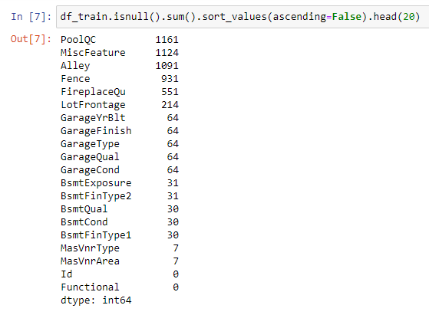

We used the below measure to treat the Null Values

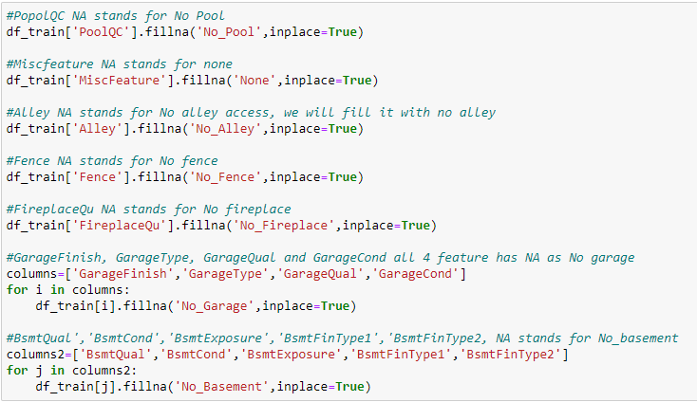

We observed that there is only one unique value present in Id so will be dropping this column..

## DATA INPUTS- LOGIC- OUTPUT RELATIONSHIPS

Here we check the correlation between all our feature variables with target variable label

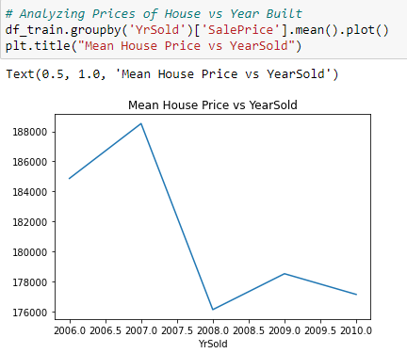

There seems to be a peak in House Prices, but a sharp drop in between 2007 to 2008

Set of assumptions related to the problem under consideration

By looking into the target variable label we assumed that it was a Regression type of problem.

We observed multicollinearity in between columns so we assumed that we will be using Principal Component Analysis (PCA).

We also observed that only one single unique value was present in Utilities column so we assumed that we will be dropping these columns.

## HARDWARE AND SOFTWARE REQUIREMENTS AND TOOLS USED

***HARDWARE:***



***SOFTWARE:***

Jupyter Notebook (Anaconda 3) – Python 3.8.5

***LIBRARIES:***

The tools, libraries and packages we used for accomplishing this project are pandas, numpy, matplotlib, seaborn, scipy stats, sklearn.decomposition pca, sklearn standardscaler, GridSearchCV, joblib.

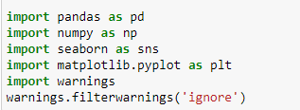







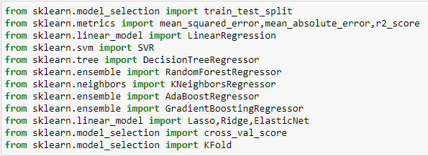

**PCA**

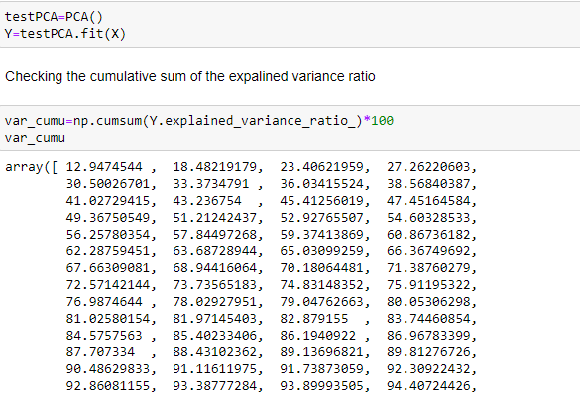

# MODEL/S DEVELOPMENT AND EVALUATION

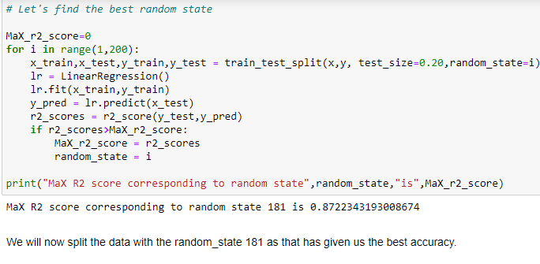

## RUN AND EVALUATE SELECTED MODELS

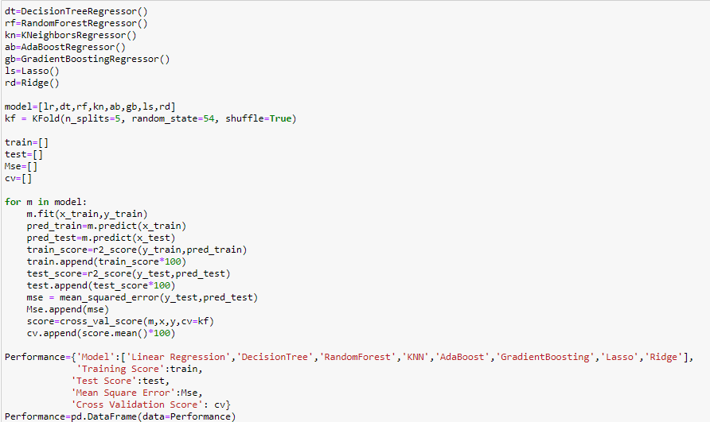

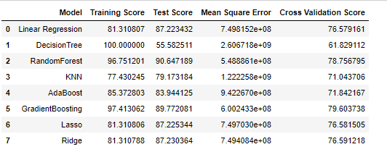

## KEY METRICS FOR SUCCESS IN SOLVING PROBLEM UNDER CONSIDERATION

We used the metric Mean Squared Error by selecting the Ridge Regressor model which was giving us best(minimum) MSE score.

## VISUALIZATION

Below technique was used for data visualization

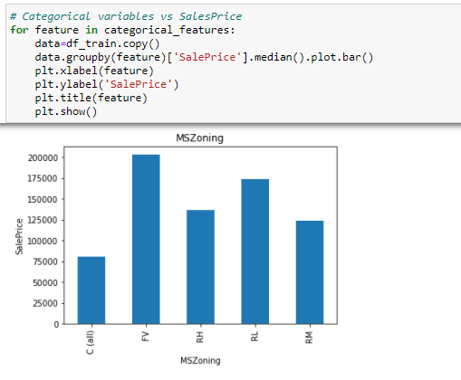

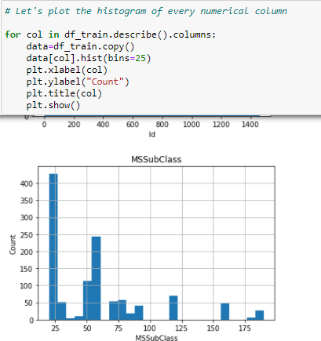

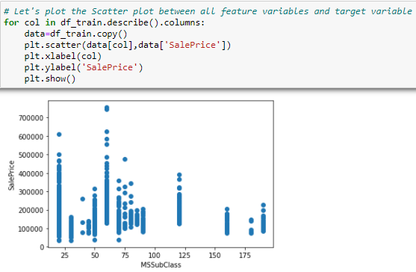

## INTERPRETATION OF THE RESULTS

From the visualization we interpreted that the target variable SalePrice was highly positively correlated with the columns GrLivArea, YearBuilt, OverallQual, GarageCars, GarageArea.From the pre processing we interpreted that data was improper scaled.

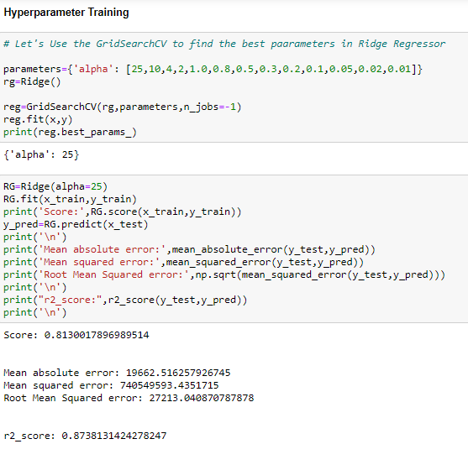

From the modeling we interpreted that after hyperparameter tuning Ridge Regressor works best with respect to our model with minimum RMSE of 27213

# CONCLUSION

## KEY FINDINGS AND CONCLUSIONS OF THE STUDY

In this project we have tried to show how the house prices vary and what are the factors related to the changing of house prices. The best(minimum) RMSE score was achieved using the best parameters of Ridge Regressor through GridSearchCV though Lasso Regressor model performed well too.

## LEARNING OUTCOMES OF THE STUDY IN RESPECT OF DATA SCIENCE

This project has demonstrated the importance of sampling effectively, modelling and predicting data.

Through different powerful tools of visualization we were able to analyse and interpret different hidden insights about the data.

Through data cleaning we were able to remove unnecessary columns and outliers from our dataset due to which our model would have suffered from overfitting or underfitting.

The few challenges while working on this project where:-

* + Improper scaling
  + Too many features
  + Missing values
  + Skewed data due to outliers

## LIMITATIONS OF THIS WORK AND SCOPE FOR FUTURE WORK

As with any project there is room for improvement here. The very nature of this project allows for multiple algorithms to be integrated together as modules and their results can be combined to increase the accuracy of the final result. This model can further be improved with the addition of more algorithms into it. However, the output of these algorithms needs to be in the same format as the others. Once that condition is satisfied, the modules are easy to add as done in the code. This provides a great degree of modularity and versatility to the project.